Monsters, Monsters Everywhere!!!
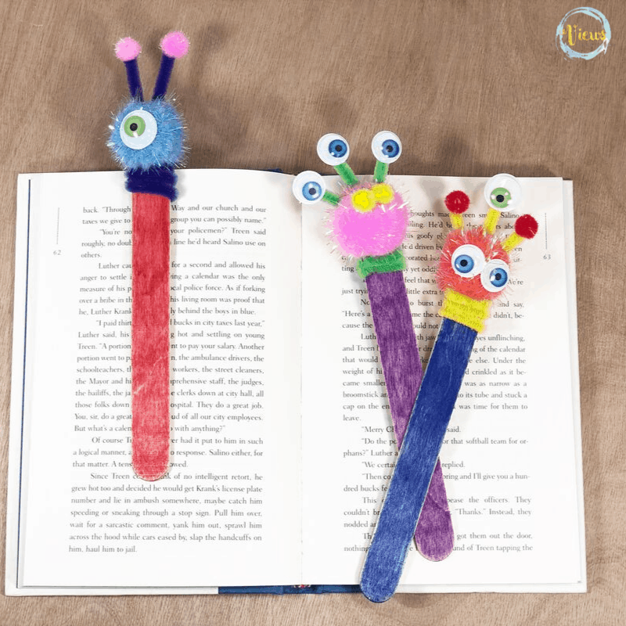
Monster Bookmark
- From you kit you will need the popsicle stick, pompoms (you will need one for the other craft), google eyes (you will need 2 for the other craft), and pipe cleaner. From home you will need glue (or glue gun), a sharp pencil, and scissors.
- Take a sharp pencil and poke a hole into the large pompom. Put a dot of glue on the end of the pipe cleaner and stick it into the hole in the pompom.
- Hold the pompom at the top of the stick and wrap the pipe cleaner around the stick three times. Cut the pipe cleaner and glue the end down.
- Create monsters by attaching the remaining pipe cleaner, google eyes, and pompoms with glue (or glue gun)
- Take a picture and post on the Merrill Public Library Facebook page (search #monsterbookmark to find the post)
- Read a book about monsters!
Crazy Hair Monsters
- From your kit you will need the plastic cup, grass seeds, soil puck, string, pompom nose, and two google eyes. From home you will need glue, water, and a sunny place to sit you monster face.
- First create you monster face by gluing on the eyes, nose, and mouth. Be creative!
- Next put the soil puck in the cup and fill it about half way with warm water. Let it sit for a few minutes for the water to absorb. Once the water absorbs you can add your grass seeds.
- Put your monster in a sunny spot and wait for the hair to grow—don’t forget to water the seeds!
- When you have hair do something funny with it (add a bow or give it a flat top)
- Take a picture and post on the Merrill Public Library Facebook page (search #monsterhair to find the post)
