Merrill Public Library
Phone: 712-938-2503
Email: merrilllibrary@mtcnet.net
Website: https://c5.merrill.lib.ia.us/

Facebook: facebook.com/MerrillPublicLibrary

Merrill Public Library is closed to the public for social distancing purposes. We are offering curbside pickup of materials by calling 712-938-2503
or by going to our website https://c5.merrill.lib.ia.us/services/proctoring-service
Watch our facebook page “Merrill Public Library” for updates!
Our weekly craft kits are going over very well! Thank you to all that have participated. We will continue to have seed kits for the month of May (this is an 8 week project with weekly facebook posts telling you what to do for the week) and at the end you will have sunflowers and green beans to enjoy!
Future kits will be:
May 4th-9th Mother’s Day flowers and gift
May 11th-16th Hedgehog book craft
May 18th -23rd Coffee filter flower craft
May 25th-30th Sand Art characters
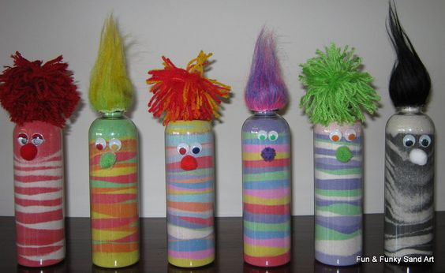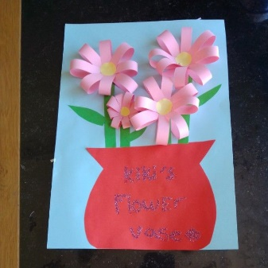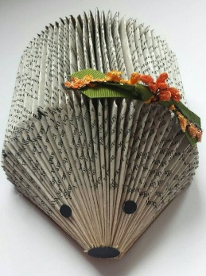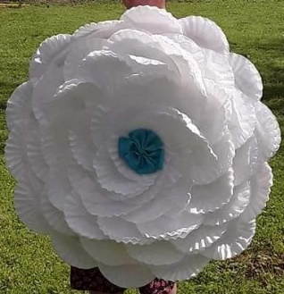
May Book Club
Thursday, May 28th, 5:30
Discussion via Zoom (link on our Facebook page)
The Girl on the Train by Paula Hawkins
We have one copy of this at the library and it can also be found on Overdrive in ebook and audiobook format.

