Merrill Public Library
Phone: 712-938-2503
Email: merrilllibrary@mtcnet.net
Website: merrilliowa.com/library.html
Facebook: facebook.com/MerrillPublicLibrary/
Hours Open:
Monday & Wednesday 2 pm to 6 pm
Tuesday & Thursday 4 pm to 7 pm
Friday & Saturday 9 am to 12 noon

Upcoming Events:
Wednesday, March 11, 2:30-3:30: Escape Room
Saturday, March 14, 10-11: St Patty’s Day Story time and craft
Thursday, March 19, 5-6: Story time
Monday, March 23, 5-6: Craft night-Bunny Garland
Thursday, March 26, 5:30: Book Club Discussion “We were Liars”
Every Friday morning, 10-11: Chair Exercise Class
Every Tuesday evening, 5:45-6:45: Exercise Class
Every Friday morning, 9-11 am: Coffee

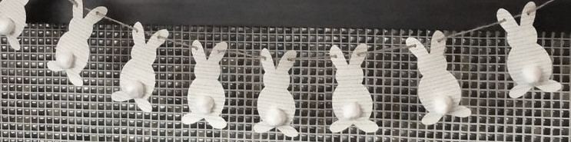

New Adult Books
Blessing in Disguise by Danielle Steel
Golden in Death: An Eve Dallas Novel by J.D. Robb
Hidden Bodies (a You Novel) by Caroline Kepnes
Summer Guests by Mary Alice Monroe
Testaments: The Sequel to the Handmaid’s Tale by Margaret Atwood
Things You Save in a Fire by Katherine Center
This is How It Always Is by Laurie Frankel
Vanishing by Jayne Ann Krentz
Winter in Paradise by Elin Hilderbrand
You by Carolyn Kepnes
Long Call by Ann Cleeves

New Juvenile Books

Baby-Sitters Club: Dawn and the Impossible Three by Ann M Martin
Baby-Sitters Club: Boy-Crazy Stacey by Ann M Martin
Baby-Sitters Club: Kristy’s Big Day by Ann M Martin
Magician’s Hat by Malcolm Mitchell
Pippi Longstocking by Astrid Lindgren
Poke-A-Dot: Who’s in the Ocean A Melissa & Doug
Should I Share My Ice Cream? by Mo Willems
Don’t Let the Pigeon Stay Up Late! By Mo Willems
I Really Like Slop! By Mo Willems
Ish by Peter H Reynolds
Willa’s Wilderness Campout by Valerie Tripp
Because I Had a Teacher by Kobi Yamada

We are starting a book club at the Merrill Public Library! We will interlibrary loan the books so we will need to know well in advance if you will be participating. You can call the library or visit our Facebook page to reserve your spot.
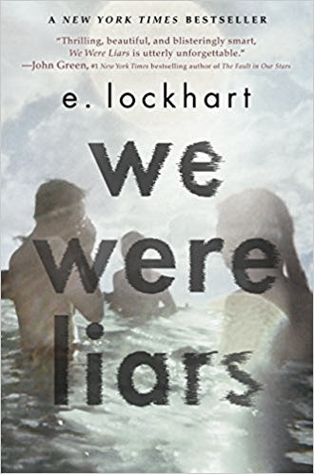
March:
Thursday, March 26, 5:30
We Were Liars by E. Lockhart
April:
Thursday, April 23, 5:30
Water for Elephants by Sara Gruen

