Website: https://c5.merrill.lib.ia.us/

Facebook: facebook.com/MerrillPublicLibrary
Phone: 712-938-2503

Email: merrilllibrary@mtcnet.net

We are open to the public and are continuing curbside pickups. Please social distance and wash your hands before coming into the library.
We are very excited to serve you!
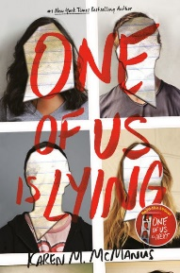
July Book Club
Thursday, June 25th, 5:30
Sign up here: https://c5.merrill.lib.ia.us/services/book-clubs
One of Us is Lying by Karen M. McManus

In an effort to simplify our processes, sometime in the near future we will be combining our library card system with our Overdrive system. That means that you will have to use your Merrill Public Library card number in the Overdrive system instead of the MP **** number. Don’t know your library card number? Please give us a call! Have you been on Overdrive? There are many, many e-books and audiobooks for you to enjoy!
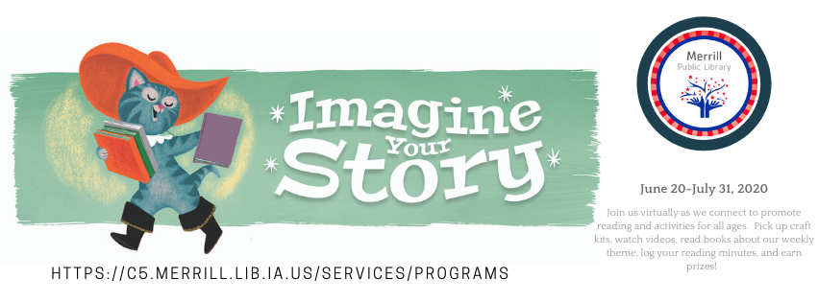
This year’s summer program is themed “Imagine Your Story” and will run June 20th thru July 31st. Since we are still practicing social distancing, our program will be online and with craft kits having to do with our theme. We will be having another reading challenge and have some extra cool prizes this time!! Earn up to 10 prizes! Watch our website and Facebook page for more details and sign up.

Books coming in July:
Children:
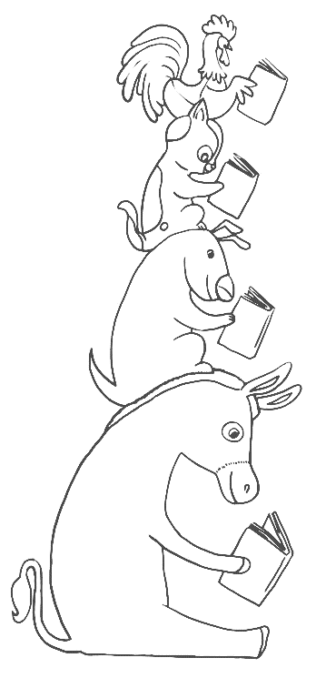
There’s a Monster in Your Book by Tom Fletcher
Three Little Pigs by Mei Matsuoka
We’re Going on a Treasure Hunt by Kelly Dipucchio
Wheels on the Bus by Annie Kubler
Hello, Neighbor! By Matthew Cordell
Hello, World! Construction Site by Jill McDonald
Little Bear’s Treasures by Stella Dreis
Berenstain Bears Storybook Favorites by Mike Berenstain
Busy Creature’s Day Eating! By Mo Willems
Curious George and the Hot Air Balloon by H.A. Rey
Amelia Bedelia Lost and Found by Herman Parish
World Needs More Purple People by Kristen Bell
You Don’t Want a Dragon! By Ame Dyckman
Ten Monsters in the Bed by Katie Cotton
Three Little Pigs: An Architectural Tale by Steven Guarnaccia
Very Last Castle by Travis Jonker
We’re Off to the Moon in my Hot Air Balloon by Rainey Leigh Seraphine
Juvenile:
Timmy Failure: Mistakes Were Made by Stephan Pastis
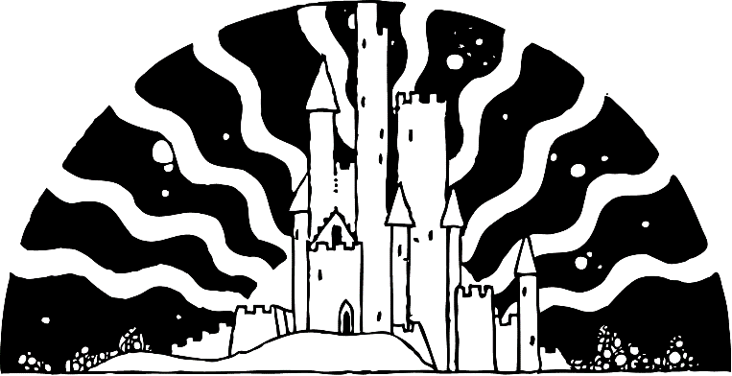
Timmy Failure: Zero to Hero by Stephan Pastis
When You Were Everything by Ashley Woodfolk
Glitch by Laura Martin
Isle of the Lost by Melissa de la Cruz
Last Kids on Earth and the Zombie Parade by Max Brallier
Rebel in the Library of Ever by Zeno Alexander
Bad Kitty Joins the Team by Nick Bruel
Boy Who Grew Dragons by Andy Shepherd
Camp Murderface by Saundra Mitchell
Echo Mountain by Lauren Wolk
Finally, Something Mysterious by Doug Cornett
Galactic Hot Dogs by Max Brallier
One and Only Bob by Katherine Applegate
Young Adult:
One of Us Is Lying by Karen M. McManus
Be Not Far from Me by Mindy McGinnis
Adult:
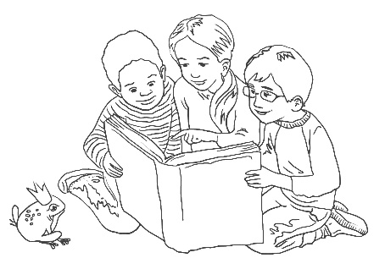
Relentless: Unleasing a Life of Purpose by John Tesh
Untamed by Glennon Doyle
Vanishing Half by Brit Bennett
Hit List by Stuart Woods
Mr. Churchill’s Secretary by Susan Elia MacNeal
20th Victim by James Patterson
Morning Comes Softly by Debbie Macomber

