Three Little Pigs
For our first craft today we are going to listen to the story posted on our Merrill Public Library Facebook page (search #3littlepigs to find it) and we will be designing the three houses the pigs built. From your kit you will need the large paper, bag of straw, legos, and stamper. From home you will need a handful of sticks and glue. On your big piece of paper draw the outline of your three houses. Use the straw to build your first house made of straw. Use the sticks to make your second house made of sticks. For your third house use your legos and stamper to make your house of bricks.
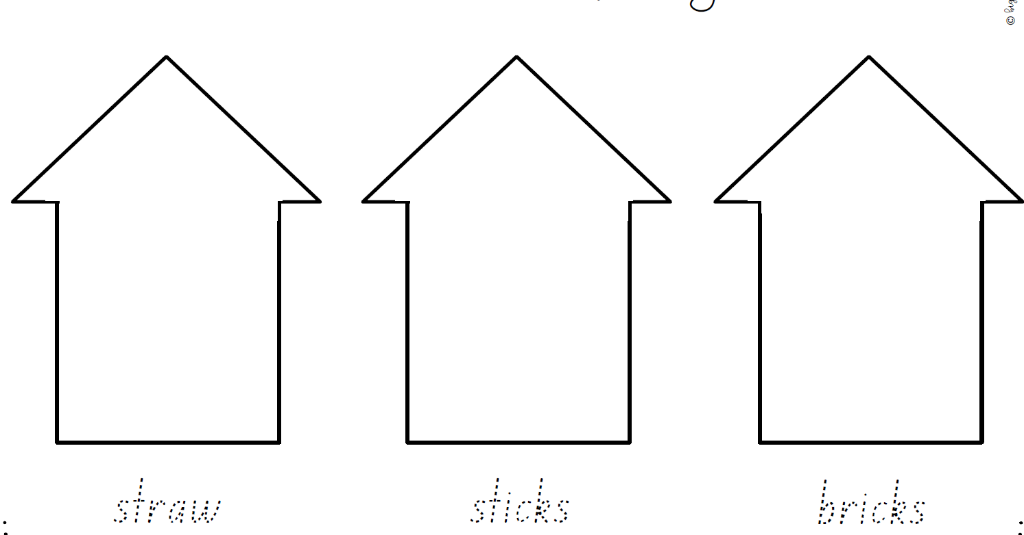
Take a picture and post it on our Merrill Public Library Facebook page (search #3littlepigshouses to find it)

Big Bad Wolf, Blow Your House Down!
Use at least 10 toothpicks and 10 marshmallows to build a house that the Big Bad Wolf can’t blow down!

From you kit you will need the wolf face and the bag with toothpicks and marshmallows. From home you will need a hair dryer and colors (or markers), tape and scissors.
Color your wolf face and cut it out.
Use the bag of toothpicks and marshmallows to build a house—try to make it sturdy!
Tape your wolf face onto your blow dryer.
Turn on the blow dryer and try to blow your house down.
Try again and again to see which house you build is the most sturdy.
(We did package the marshmallows with gloves but please don’t eat them!)
Take a picture and tell us your results on our Merrill Public Library Facebook page (search #blowyourhousedown to find the post)

Color your coloring page and post it on our Merrill Public Library Facebook page (search #threehousecoloringpage to find the post)
