This week we are going to get creative designing our own castles! From your craft kit you will need your big foam paper and the foam shapes for the structure of your castle. From home you will need glue and various items to decorate around and on your castle.
Start by laying out your castle, think about how people would enter it and how it would be protected from outsiders. Once you have it all laid out, glue it down. Have fun!!
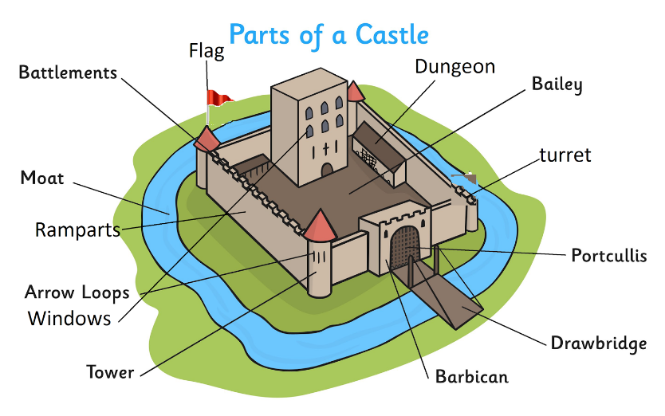
Next you are going to make a catapult! From your craft kit you will need the 6 sticks, 4 rubber bands, ½ egg, and pompoms.
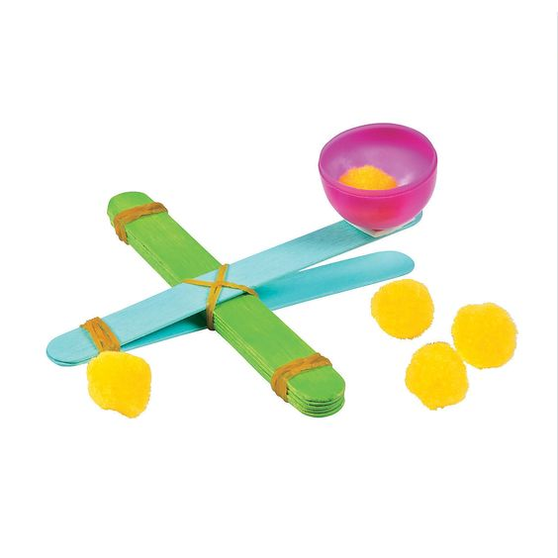
- Start by stacking 4 of the sticks together and wrapping a rubber band around both ends
- Stack the remaining two sticks together and wrap another rubber band around one end
- Open the stack with two sticks and place the stack with 4 sticks in between them
- Use your remaining rubber band wrap around all of the Popsicle sticks to hold the catapult together. We wrapped it in an X, across and around several times.
- Glue (hot glue works best) the ½ egg on the end of the top stick
- Put the pompom into the egg and press down on the end of the stick
- Release the stick and watch your pompom fly
Can your pompom land in your castle? What is the furthest you could be back before you couldn’t reach the castle any more?
Don’t forget to share your castle and your catapult results on the Merrill Public Library website or Facebook page (search #castle #catapult #castlecoloringpage to find the post)
