Treasure, treasure all around…
treasure, treasure what is lost can be found
This week we are building a treasure box for you to put all your tiny treasures into! From your craft kit you will need all the popsicle sticks and the charms. From home you will need glue and optional paint or markers.
First lay down 12 sticks to create a square (see picture). You will need two of these, one for the base of the treasure chest and one for the lid. Run a stripe of glue along both edges and place a popsicle stick on that glue. On the base continue to place a dab of glue on the corners and place a stick across each end. Continue to do that until you are out of sticks. Don’t try to move your treasure chest until it is dry. Once it’s dry add your charms to decorate it!
If you would like a colorful chest you can paint or draw on the sticks before you put it together.
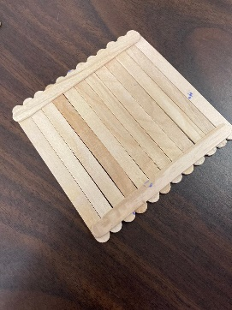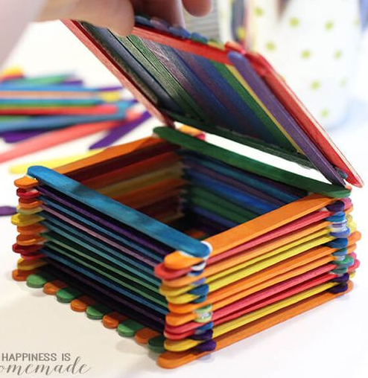
Next we are going to be “digging for treasure”. Take your bag of play dough and have fun finding the treasure inside! Share on our Merrill Public Library Facebook page what you find!
