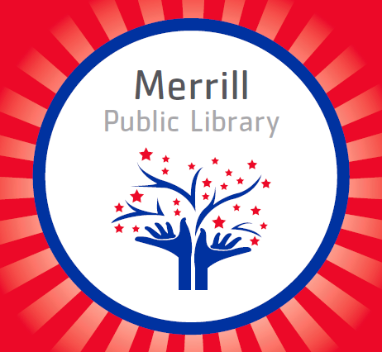
Website: https://c5.merrill.lib.ia.us/

Facebook: facebook.com/MerrillPublicLibrary
Phone: 712-938-2503

Email: merrilllibrary@mtcnet.net

We are open to the public and will continue curbside pickups. Please social distance and wash your hands before coming into the library.
We are very excited to serve you!

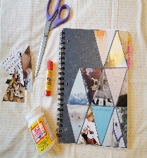
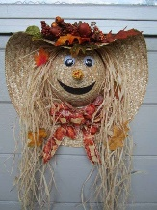
This month we are doing two craft kits!! The first is a family kit where you will be making a Cowboy Hat Scarecrow Wreath. The second is an ALL AGE CRAFT (yes-that means adults can take this one). It is a personally designed notebook. These crafts will be available September 1st and are first come, first serve. You can get these by curbside pickup if you would like.

As we navigate the changing times with Covid we are also adapting to these changes. If you are not comfortable coming into the library we do offer other options to serve you.
Curbside pickup: You can either call ahead and we will pull the books you would like or browse our online catalog and reserve the books you would like online.
To reserve online:
- Go to https://c5.merrill.lib.ia.us/
- Click catalog search along the top
- In the top corner of the next page, click log on
  - Your log in is your library card number and a password-If you do not know this information, please call 938-2503 and we will get you set up
- Once logged in use the search bar to look for books by subject, title, or author
- Once you find a book you would like, click on it and in the left hand side of the summary, you will find a reserve button
- Click the reserve button, which will take you to another screen to click reserve from the main library, and then press reserve again to confirm your reservation
- We will then get a message to pull those books for you
E-books or audiobooks:
- Go to https://c5.merrill.lib.ia.us/ebook-audio
- Click the link to go to bridges
- Click sign in
- Choose Merrill Public Library
- Enter your 8 digit library card number
- Search the library for books you would like to read
- Place holds to get in line for popular books
- Libby is an app you can get to make it easy to read from your devices

Books coming in September:

Children:
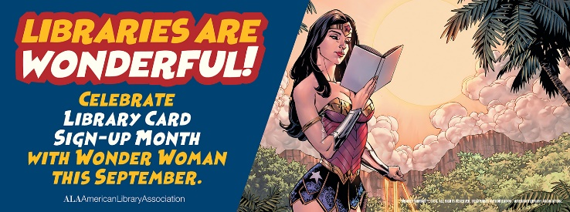
Pout-Pout Fish and the Can’t Sleep Blues by Deborah Diesen
Sheep in a Jeep by Nancy E. Shaw
From Head to Toe by Eric Carle
Three Cheers for Kid McGear! By Sherri Duskey Rinker
What Color is Night? By Grant Snider
The Remember Balloons by Jessie Oliveros
How to Catch a Mermaid by Adam Wallace
Elbow Grease vs. Motozilla by John Cena
Hike by Pete Oswald
Little Monster Trucks Go! By Doug Cenko
Let’s Play, Crabby by Jonathan Fenske
Wake Up, Crabby by Jonathan Fenske
Jack Blasts Off by Mac Barnett
Juvenile:
Nerviest Girl in the World by Melissa Wiley
Who Were the Beatles? by Geoff Edgers
Who Was Gandhi? By Dana Meachen Rau
Who Was Stan Lee? By Geoff Edgers
Why, Fly Guy? Answers to Kids’ Big Questions by Tedd Arnold
Dog Man: Fetch-22 by Dav Pilkey
Who Would Win?: Ultimate Showdown by Jerry Pallotta
Dog Man: Grime and Punishment by Dav Pilkey
Zatanna and the House of Secrets by Matthew Cody
Hollow City: The Second Novel of Miss Peregrine’s Peculiar Children by Ransom Riggs
Rainstorm Brainstorm by Valerie Tripp
Clippity-Cloppity Carnival by Valerie Tripp
Guinness World Records: Science & Stuff
Bigfood Goes on Vacation (Seek & Find) by D.L. Miller
Young Adult:
The Sun Is Also a Star by Nicola Yoon

Adult:
Book of Longings by Sue Monk Kidd
Deacon King Kong by James McBride
Great Alone by Kristin Hannah
This Tender Land by William Kent Krueger
Last Mission to Tokyo: The Extraordinary Story of the Doolittle Raiders and Their Final Fight for Justice by Michel Paradis
Truths I Never Told You by Kelly Rimmer
Things We Cannot Say by Kelly Rimmer
Last Ditch (Caught Dead in Wyoming, Book 4) by Patricia McLinn
Girl Next Door by A. J. Rivers
Girl and the Deadly Express by A. J. Rivers
We will be suspending our book clubs for the next few months-if you are interested in starting a book club we would love to work with you and get one started!

